Coordinators Training Manual for Regularly Scheduled Series (RSS)

Rutgers Single Sign-On (SSO) Users

CloudCME v.February 2019
RU v. August 2019

All rights reserved © 2017, 2019

Table of Contents
Table of Contents 2
RSS Dashboard Introduction 3
RSS Icons 4
RSS Status Definitions 5
Editing an RSS Child Activity 7
Approving RSS Child Activities 12
Adding an RSS Child Activity 12
Disclosure Report 14
Attendance Recording - SMS Texting 17
Credit Manager 19
Appendix I – Uploading the Flyer 20
Appendix II - Add Member 21

RSS Dashboard Introduction
CloudCME® offers the RSS Dashboard to assist in easily managing individual RSS sessions or children, as they are often referred to. Via the RSS Dashboard, you can enter in the child activity title, location, objectives, and specialties, assign faculty, manage faculty disclosures and upload faculty presentations.
First, go to https://rutgers.cloud-cme.com/ and log into CloudCME® by clicking “Sign in with your Rutgers NetID,” enter your NetID, password and click the Login button.

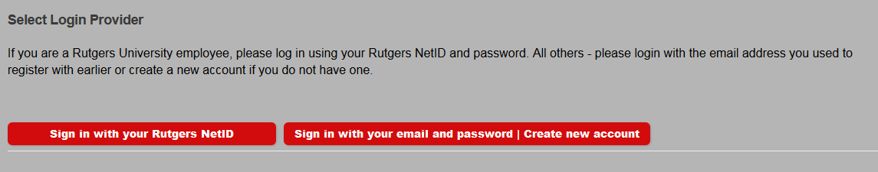

On the lower-left hand side of the screen, you will see a field with “Administration.” Click on the word “Administration.”

NOTE: An Administrator must assign permission to your account in order for you to view this screen. If you do not see “Administration” or have access to the RSS Dashboard (see below), please contact Elizabeth Ward (elizabeth.s.ward@rutgers.edu / 973-972-3605), Sandie Gallt (galltsa@rbhs.rutgers.edu / 973-972-0076) or Patrick Dwyer (patrick.dwyer@rutgers.edu / 973-972-8377).
Select Activities from the main menu and then select RSS Dashboard from the sub-menu. This screen may vary depending on what access you have been given.

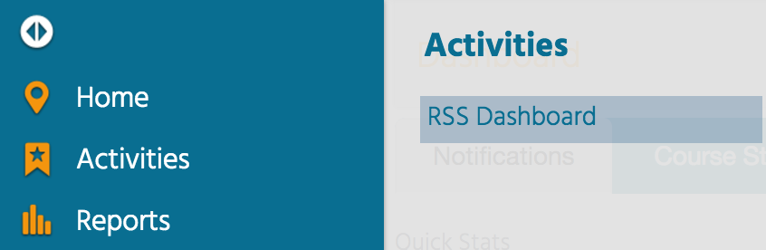

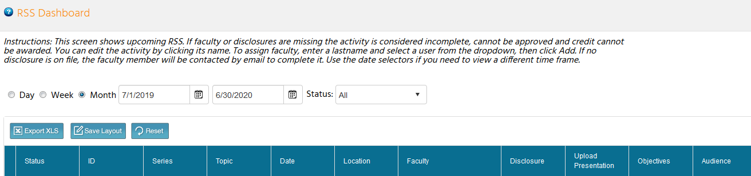

RSS Icons

There are icons in three columns of the RSS Dashboard: Status, Topic and Faculty, and below is the purpose of each icon.
Status column - This column contains a status icon. As the planning process continues through the approval state, the icon displayed in this column will continue to update. NOTE: Please refer to the RSS Status Definitions below for a description of each status meaning.
Topic column - The first icon is that of the handout. While we will not be using this to generate the handout (flyer), you will use this to upload the flyers that you create for each session.
NOTE: Please refer to Appendix I – Uploading the Flyer.
The second icon is that of the calendar. Click this icon and the calendar will display for you to view and access the scheduled RSS child activities.

Lastly, is the trash can icon. Click this icon to deactivate an RSS child activity.
Faculty column - This column contains three icons for your use. The first is the green plus icon. Once you have selected the faculty member from the drop-down list, click this icon to add the user as a faculty member for this RSS child activity.

Once a user has been added as a faculty member, two additional icons display. The first is an envelope icon. Click this icon and a pop-up window will display for you to create an email message to send to the faculty member.

Lastly, you see a red minus icon. Click this icon to remove a faculty member from the RSS child activity.

Upload Presentation column - An icon displays in this column when one or more faculty have disclosed a financial relationship in the disclosure form. This icon signals to upload the faculty member's presentation so that the peer review process can begin.

RSS Status Definitions
Incomplete: This status means that faculty and disclosure have not been assigned yet. Coordinators/Owners will see Incomplete by default until faculty have been assigned and disclosures have been completed. This is the initial default status of every RSS child activity.
Pending: This status represents faculty who have completed a disclosure and there was no Conflict of Interest (COI) disclosed (i.e. nothing was disclosed or COI was resolved).
In Review: This status represents faculty who have a completed disclosure and a potential Conflict of Interest has been noted. The faculty member’s presentation has been uploaded, triggering a formal review for identified conflict of interest to determine if resolution is needed.
Approved: This represents faculty who have completed a disclosure, either no conflict of interest identified or, if identified, resolution of conflict of interest has been satisfactorily completed.
Rejected: This represents faculty who have completed a disclosure, a conflict of interest has been identified and the conflict of interest is not able to be satisfactorily resolved. The activity is rejected. The coordinator would remove this faculty member and would need to select a new faculty member and begin the process again.
The RSS Dashboard provides a minimized view to easily manage RSS activities. You will see all of the activities that you have been assigned as coordinator/owner except those that are approved unless Approved is selected in the Status search method.
There is a variety of methods to search the RSS Dashboard. You can search by frequency (i.e. day, week or month), date range or status.
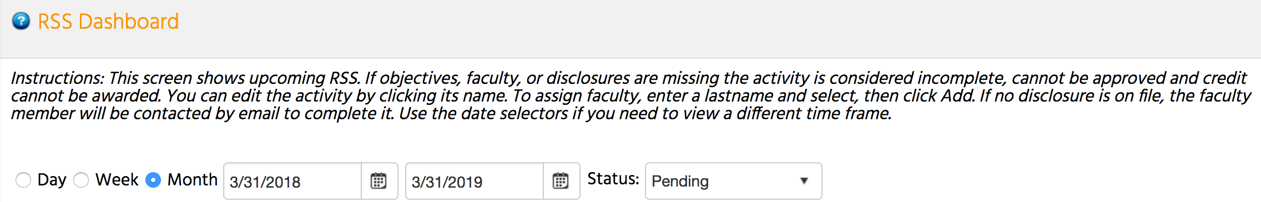

In the screenshot below, you can see a date range has been entered and the Status is set to Pending. You can also search by changing the status to All, In Review, Incomplete, Approved or Rejected.

NOTE: Please see the section titled, "RSS Status Definitions" provided above for a definition of each available status.
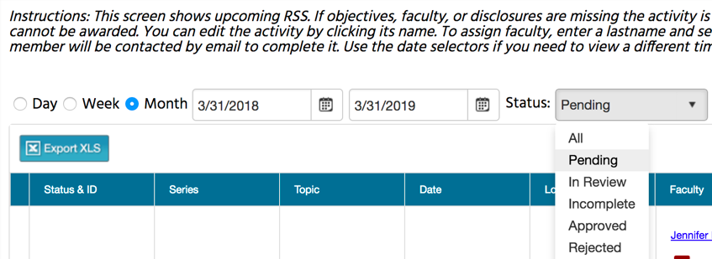

Editing an RSS Child Activity
The data table below contains several columns of data to assist you in managing the activity planning process. Columns include: Status, ID, Series, Topic, Date, Location, Faculty, Disclosure, Upload Presentation, Objectives, and Audience.
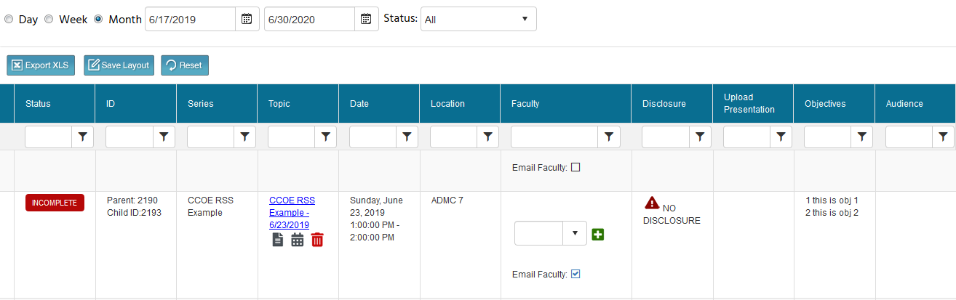
Click on the activity title (topic) that you wish to edit and the activity screen will display. You can now edit the detail and click the “Save” button.

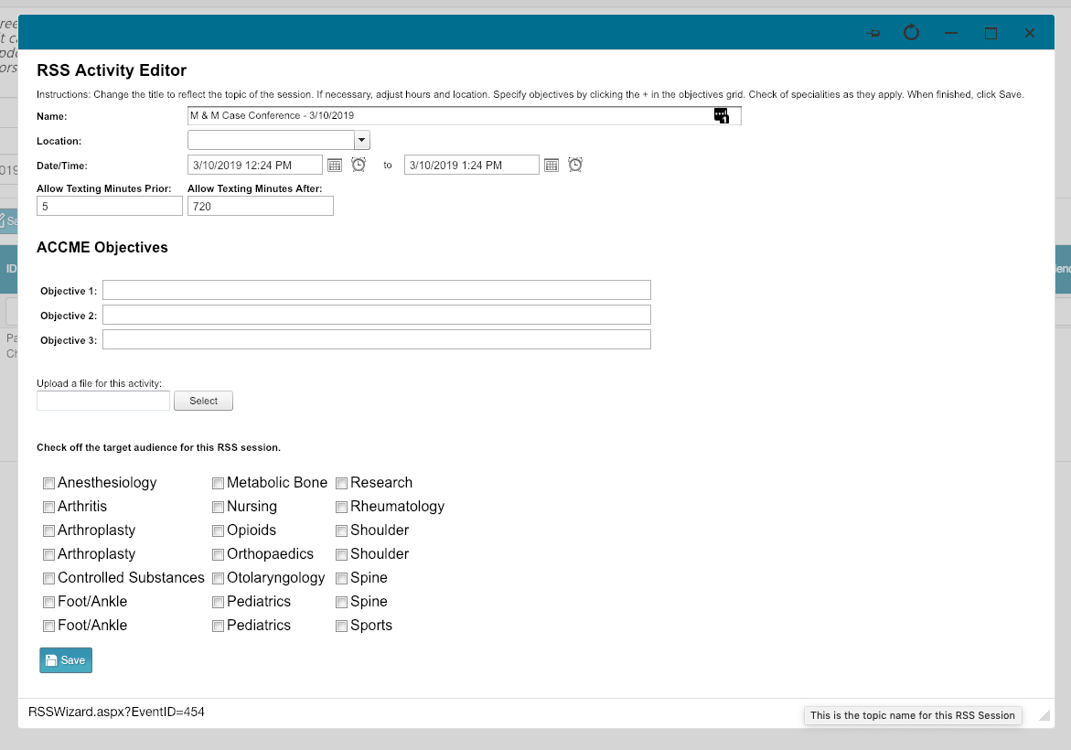

You can edit the RSS child activity Name, Location, Date/Time, Objectives, Upload a file for this activity and select the specialties that are the target audience for this activity. DO NOT EDIT the Allow Texting Minutes Prior and Allow Texting Minutes After.

NOTE: The child activity title will appear on users’ transcripts as you have entered it into the field.

When all information has been entered, click the “Save” button.
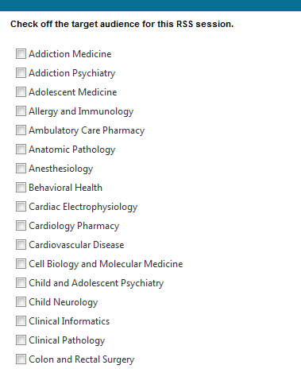
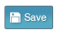
Begin to add your identified faculty (speakers) to your child activity in the Faculty column. Type in the first few letters of the faculty member's last name, select them from the drop-down list, and click the green + button.

NOTE: If the faculty (speaker) does not have an account in CloudCME® and the faculty (speaker) has a Rutgers NetID, please have him/her complete the following steps:
- Go to: https://rutgers.cloud-cme.com
- Click “Sign In” in the upper left corner of the screen.
- Select “Sign in with your Rutgers NetID.” Please be sure you sign in with your Rutgers NetID and Password; CloudCME is integrated with Rutgers Single Sign-On.
- Enter your Rutgers NetID and Password on the Central Authentication Service screen
- Your profile screen will appear. Please complete your profile and click submit at the bottom of the screen.
  - If the profile screen does not appear, this means you already have an account. You can use this time to make sure your profile is up-to-date (Click “My CE” then “Profile” on the top menu bar to view your profile.)
NOTE: If the faculty (speaker) does not have an account in CloudCME® and does not have a Rutgers NetID, you will need to add the faculty member to the system through the Membership Manager. See Appendix II - Add Member.
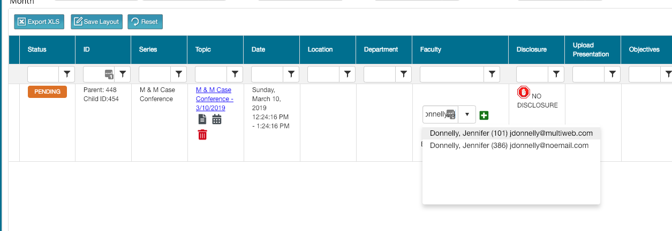

Once you click the green + button, you will see that the faculty member has been added to the child activity.
NOTE: You may see that the status in the Status column changes from PENDING to IN REVIEW. The status can change to IN REVIEW because the faculty member declared a financial relationship within their disclosure on file.
NOTE: By default, added faculty members will receive an email upon being added to the child activity. If the faculty member does not have a disclosure form in CloudCME, the email will contain a link to the disclosure form and request them to complete it. If the faculty member does not have a disclosure form in CloudCME, the email will ask them to revise their disclosure form if they have any new financial relationships. If you are using the same faculty members week after week and you know that there is already a disclosure form on file, you can uncheck the “Email Faculty” box before adding the faculty member so they do not receive an excessive amount of emails from CloudCME.
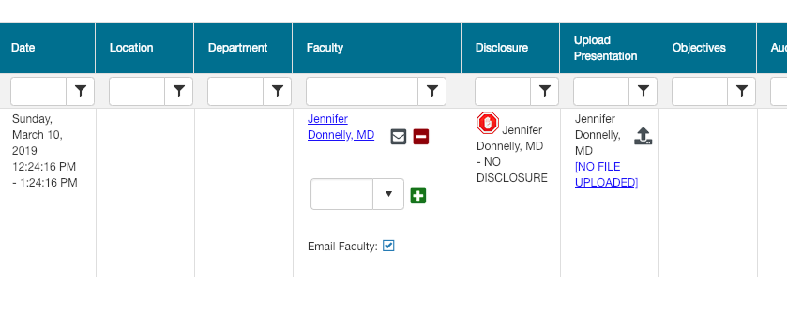
If the faculty member declares that they have no financial relationships on their disclosure form, the status will update to Pending and the RSS child activity is ready to be marked as Approved by the Activity Administrator (CCOE staff). Once approved, the status changes to COMPLETE.
If the faculty member declared a financial relationship(s), this will be noted in the Disclosure column and the status will update to IN REVIEW.
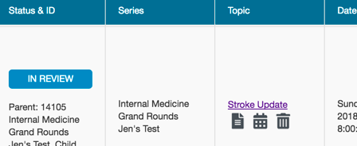
If faculty have one or more disclosed financial relationships, you will be instructed to obtain and upload the presentation (PPTX, PPT or PDF), which then triggers a peer review form. Additionally, the status changes to IN REVIEW on the dashboard.

NOTE: Click the upload iconin the Upload Presentation column to upload the faculty member’s presentation for peer review.
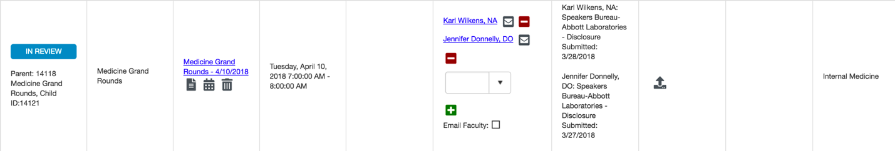
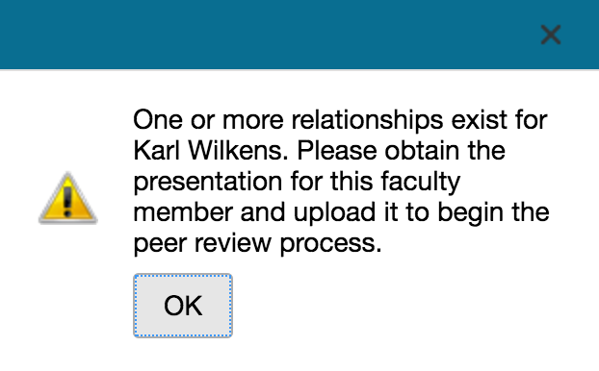
Once the faculty member's presentation has been uploaded, users who have a role of Peer Reviewer, receive an email with a link to the Peer Review form. If the Peer Reviewer does not receive an email, please be sure they check their spam folder. If the email is in their spam folder, they should approve the sender. The presentation title, faculty name, a link to the uploaded presentation, stated disclosures, and resolution questions are included within the form. Based on the question responses, this will change the status to Rejected or Pending.

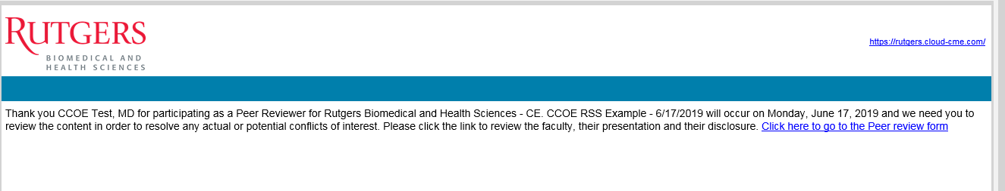

NOTE: The first peer reviewer that completes the review and Peer Review form is all that is needed. If additional peer reviewers try to complete the Peer Review form, they will receive a notification that the review has been completed and no further action is needed at this time.

NOTE: Your series has been set up with at least one peer reviewer. To add additional peer reviewers, please contact Elizabeth Ward (elizabeth.s.ward@rutgers.edu / 973-972-3605), Sandie Gallt (galltsa@rbhs.rutgers.edu / 973-972-0076) or Patrick Dwyer (patrick.dwyer@rutgers.edu / 973-972-8377).

Approving RSS Child Activities

In CloudCME®, RSS Coordinators/Owners cannot approve RSS child activities. An Administrator (CCOE staff) must approve the RSS child activities. RSS child activities will not be awarded credit unless an Administrator approves them. An Administrator cannot approve an RSS child activity without disclosures on file. Furthermore, if the faculty has a relevant financial relationship, an Administrator cannot approve the child activity until the presentation has been uploaded and the Peer Reviewer completed the Peer Review Form.
An RSS child activity must be in PENDING status no later than one (1) week prior to the session date. This means that speaker disclosures are on file, and that either there were no relevant financial relationships disclosed or that potential or actual conflict of interest was resolved through peer review.

Adding an RSS Child Activity

RSS Child Activities were set up based on the schedule information provided in your RSS application. If you need to add a new child activity, you can click on any calendar icon in the Topic column.
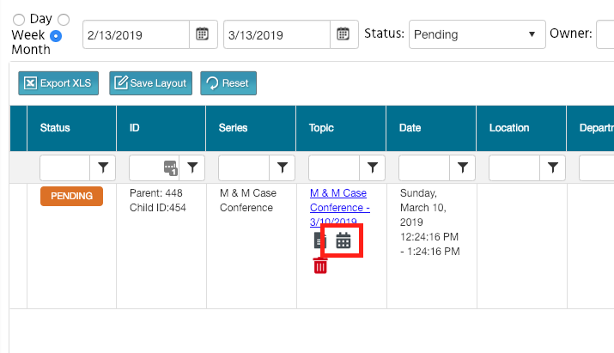
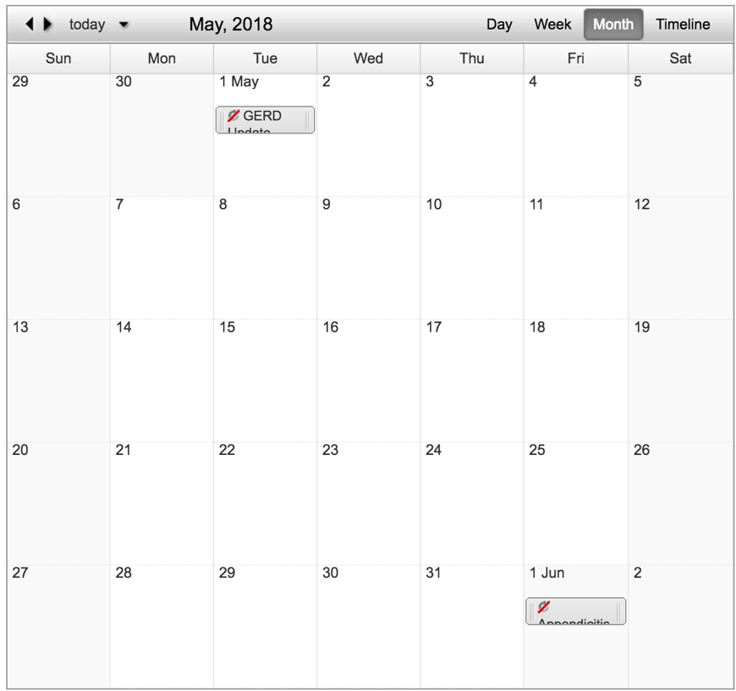
Double click on the date in the calendar for which you want to add a child activity.
Add title of the child activity and click Save.
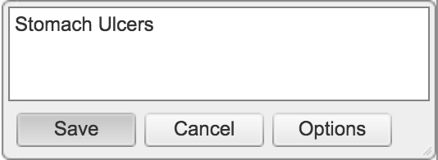
The new child activity will now appear in the RSS Dashboard and you can edit the child activity details by clicking on the Topic (title) in the RSS Dashboard to open the RSS Activity Editor.

Disclosure Report
The Faculty Disclosure Report allows you to search for completed disclosures by activity or by individual. Searching by Activity will result in the most recent faculty completed disclosures displaying. If searching by Individual, you can choose to select a faculty member's disclosure by completion date or display all disclosures completed by a faculty member.
To view faculty disclosures, select Reports > Faculty - Disclosures.
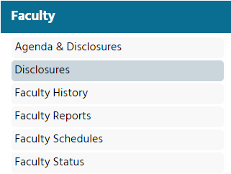

Search for an activity name in the search field and select the activity name from the drop-down list to find disclosures associated by activity.

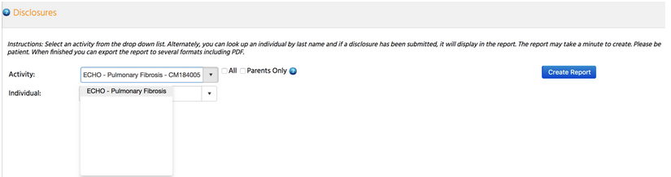

Once you select the activity, click Create Report.

NOTE: Searching by an Activity will return all the activity faculty members' disclosures.

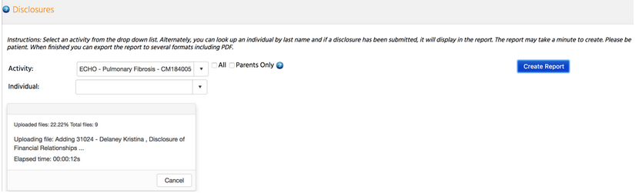

Once the report has finished, a PDF of the results will display. Click the Download PDF link and the report will display to allow you to review, download or print each faculty member's completed disclosure form.

To find an individual's disclosure, enter the last name in the Individual field.

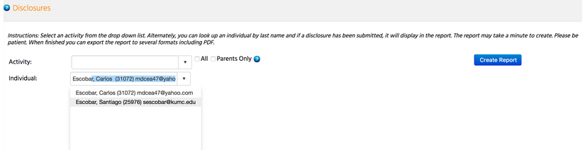

If the faculty member has completed multiple disclosures over time, you will see a message stating "Multiple submission were found. Click a date to view." Select the date of faculty member's disclosure you will like to access.

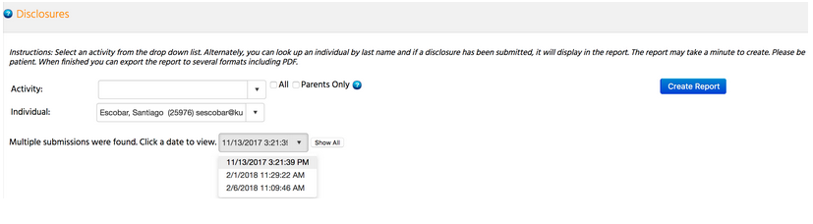

The system will render the faculty member's disclosure that was completed on the date you selected.

You can select "Show All" and the system will render every completed disclosure for that faculty member.

A blue hyperlink is available for PDF format, "Download PDF." Additionally, you can download the file or print the file.

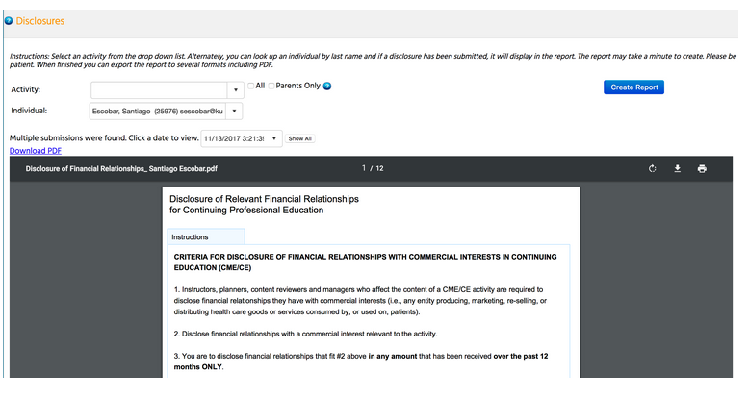

Attendance Recording - SMS Texting

Each individual will record RSS attendance by SMS text messaging using his or her mobile phone. In order for SMS text messaging to work, the following are necessary:

- Users must have an active profile in CloudCME® and need their mobile phone numbers linked to their profile (See Step 1 below). If a user does not have a profile, it must be set up first.

- The Child ID will need to be distributed at the RSS session. The Child ID can be found in the ID column in the RSS Dashboard.

- Users must send an SMS text message and not an iMessage.

- The SMS text message can only be sent during the session or 12 hours after the session.

- The session must be in APPROVED status.

Step 1: First, users must pair their mobile phone to their account in CloudCME®. Users must text the email address, entered in the user’s profile, to 732-253-4415.

Users will receive a message that looks like the one below, that their phone number has been updated. This is a one-time operation.

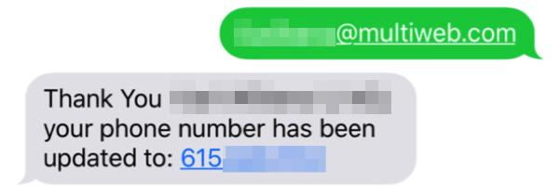

NOTE: Since there are many variations of Rutgers email addresses, users may receive an error message if they do not text the email address associated with their NetID. If users receive an error message when attempting to pair their phone, they should contact their departmental RSS coordinator who can verify which email address to use.

Step 2: To record attendance to a session, users must text the Child ID that has been provided for the session. Users can only record their attendance during the session or 12 hours after the session. Users will receive a message back that verifies their attendance has been recorded.

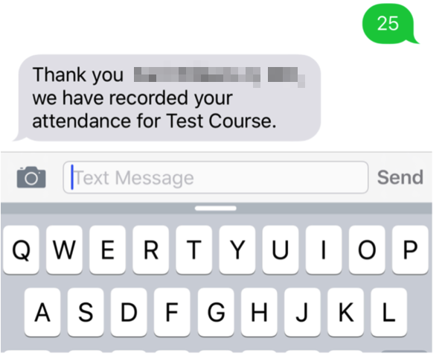

NOTE: Users can only record attendance once to a session. If users try to record their attendance an additional time, they will receive the following message.

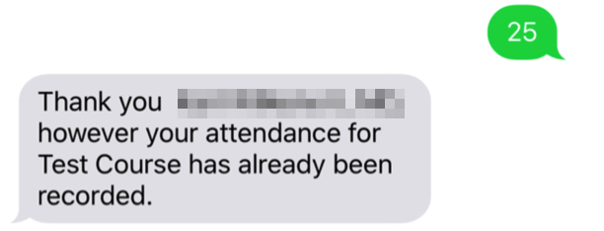

If users attempt to use a Child ID that does not exist, they will receive the following message.

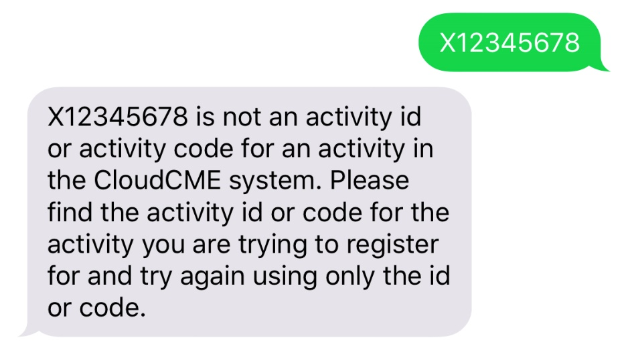

If users attempt to record attendance to a session that is not approved, they will receive the following message.

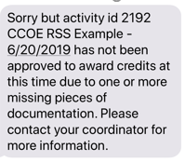

Credit Manager

While the majority of the RSS participants will text their attendance in order to be awarded the continuing education credit, there may be occasional instances where a participant is unable to text their attendance or a credit record needs to be revised or deleted. When this occurs, please contact Sandie Gallt (galltsa@rbhs.rutgers.edu / 973-972-0076).

Appendix I – Uploading the Flyer

In the Topic column on the RSS Dashboard, click on the icon to upload the flyer for the RSS Child Activity.

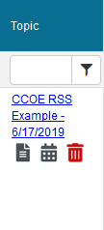
Follow the instructions on the screen below to upload the flyer.

NOTE: Faculty must be assigned to a child activity before you can upload a flyer.

NOTE: The flyer must be in Word in order to upload.

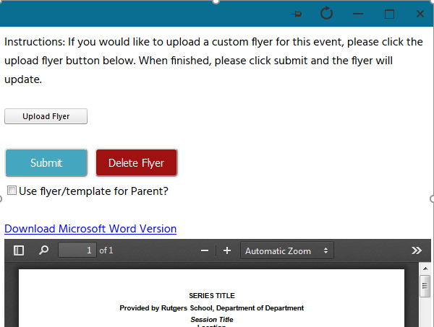

Appendix II - Add Member
To add a new member in the system, go to main menu and click Membership > Add Member.
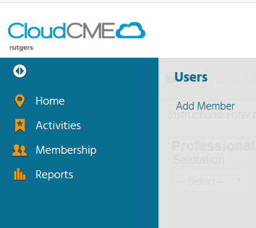
Professional Information
Enter the new member's professional information. At minimum, enter First Name, Last Name, Degree, and Title. Disregard Induction Date and Last Training Date.
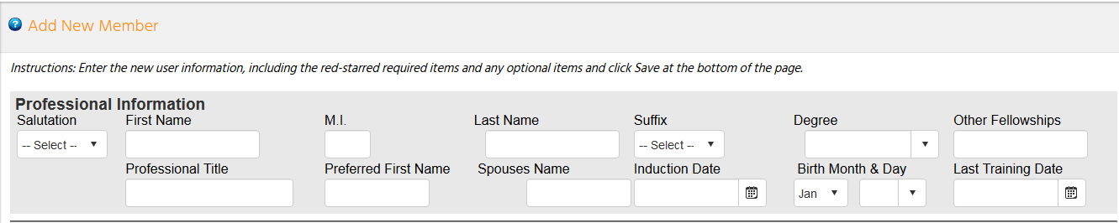
Credentials
You do not need to enter any information in the Credentials section.
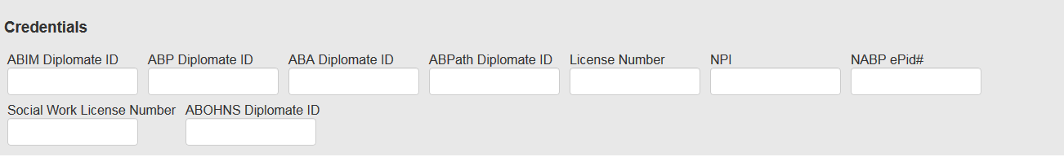
Login Information
Each user must have a unique email.
NOTE: Properly formatted email addresses can only be entered in the email fields. For example, "johnsmith" is not a valid email address. It should be formatted as 'johnsmith@domain.com.'
You must assign a temporary password in order to add a new member. Please follow this temporary password naming convention:
- UPPERCASE first initial of first name
- Last name
- 19
- !

For example, John Smith’s temporary password would be “Jsmith19!”.
NOTE: Check “Do Not Send New Member Email” if you do not want new members to receive an automated email from CloudCME notifying them that they have been added to CloudCME.
Employment
You do not need to enter any information in the Employment section.
Primary Contact Information
Enter the member’s primary contact information.
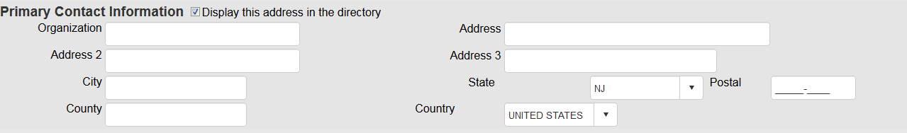

Secondary/Alternate Contact Information
Enter the member's secondary contact information, if applicable.
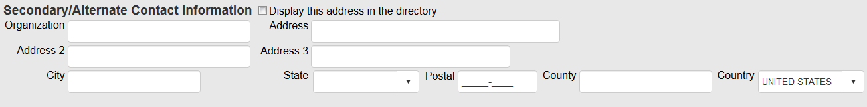
Phone Numbers
Enter the member's phone information.
Assistant Contact Information
It may be advantageous to enter the member's administrative assistant contact information if the member serves as faculty. The administrative contact is copied on all faculty email correspondence.
Emergency Contact
You do not need to enter any information in the Emergency Contact section.
Comments
Comments can be entered such as food allergies and other items of interest.

Opt-Out Options
Do not select any of three opt-out options
Credit Eligibility
Select the credit types that the member is eligible for continuing education credits.
NOTE: Both AMA PRA Category 1 Credits™ and Non-Physician Attendance may not be selected at the same time. Only one or the other may be selected for a user.
If you are unsure of the credit eligibility, select AMA PRA Category 1 Credits™ for all physicians and Non-Physician attendance for everyone else.
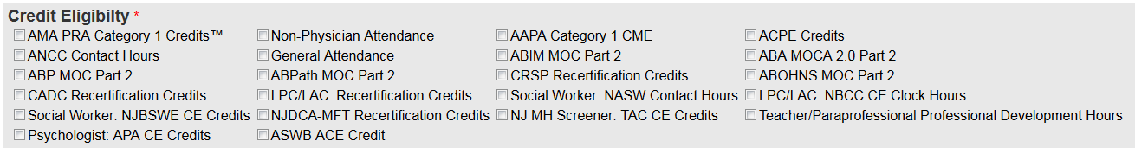
Roles
Select “Faculty” as the member's role.
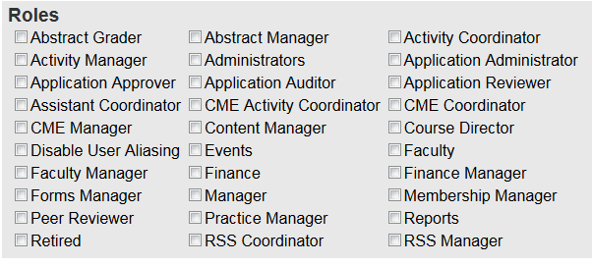

Practice Area
Select the member's areas of practice. Click on the drop-down list to select the specialty(ies).
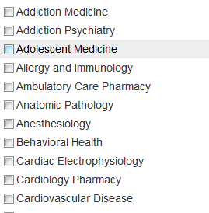
When all information is entered, and roles are assigned, click the Save button at the bottom of the screen. A message will appear informing you of success, or provide guidance if a required field needs to be filled in.

You must text an SMS text message not an iMessage, if using iOS.

