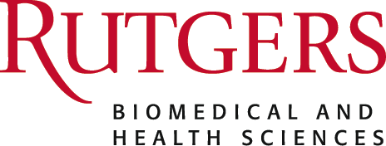

Hope and Resilience: Cultural Relevance in Palliative Care
Topic: <p>As the landscape of palliative care continues to evolve, it is crucial to recognize and address the diverse cultural needs and preferences of patients and their families. This conference aims to foster a deeper understanding of the role cultural relevance plays in providing&nbsp;compassionate care to individuals facing serious illness.<br></p>
Purpose or Objectives: At the conclusion of this activity, the participant will be able to:
1 Facilitate discussion and develop an action plan to mitigate cultural bias and promote inclusion.
2 Understand the concept of implicit bias and its impact on palliative care.
2 Recognize personal bias and gain insight on how these biases may influence perceptions and behaviors.
Date/Time: 9/18/2023 9:00:00 AM

Location 100 George St, New Brunswick, NJ 08901

Accreditation:

In support of improving patient care, Rutgers Biomedical and Health Sciences is jointly accredited by the Accreditation Council for Continuing Medical Education (ACCME), the Accreditation Council for Pharmacy Education (ACPE), and the American Nurses Credentialing Center (ANCC), to provide continuing education for the healthcare team.

PHYSICIANS: Rutgers Biomedical and Health Sciences designates this live activity for a maximum of 5 AMA PRA Category 1 Credits™. Physicians should claim only the credit commensurate with the extent of their participation in the activity.

NURSES: This activity is awarded 5 contact hours. Nurses should only claim those contact hours actually spent participating in the activity.

SOCIAL WORKERS: Pending for 5 CE hours for NJ & NY social workers.

Method of Participation

In order to meet the learning objectives and receive continuing education credit, participants are required to attend for the duration of the webinar and complete the online evaluation form at the conclusion of the activity. A letter certifying attendance and credit certification will be available, upon completion of the evaluation, via your CloudCME portal.

Planners and speakers have no conflicts of interest to disclose regarding this educational activity. There is no commercial support for this activity.
Disclosure of Financial Relationships:
The planners, moderators or speakers of this RSS have the following financial relationship(s) with commercial interests to disclose:
Aziz Ansari, DO

