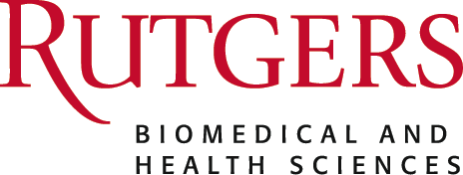

**UBHC - CCE: Basic Life Support CPR First AID (8/13/2024 Morning)**

***Topic:*** <p>&nbsp;</p><p>This course provides a re-certification for Nurses and Physicians in Basic Life Support (CPR).&nbsp; The certification is valid for two years after successful completion.&nbsp; Employee Program is charged for eligible UBHC employees.&nbsp; Check with your supervisor to ensure your course fee is covered.&nbsp;&nbsp;</p><p>Certification Requirements:</p><ul><li>Attend and participate in all course sessions.&nbsp;</li><li>Demonstrate competency in all required skills listed on the skills checklist.</li><li>Pass each section of the written exam with a score of 84% or better.&nbsp;&nbsp;</li></ul><p>Reminders:</p><ul><li>Dress Comfortably (some activities require movement)</li><li>No food or drink is provided</li><li>Temperatures vary between rooms.&nbsp; Dress in layers</li></ul><p style="text-align: center;">For further information about registration call Center for Continuing Education at cce@ubhc.rutgers.edu</p>

***Purpose or Objectives:*  At the conclusion of this activity, the participant will be able to:**

***Date/Time:*** 8/13/2024 8:00:00 AM

***Location*** *151 Centennial Avenue*

***Accreditation:***

***Disclosure of Financial Relationships:***

*The planners, moderators or speakers of this RSS have the following financial relationship(s) with commercial interests to disclose:*