August 23, 2021

RE: The 27th GI Symposium: Gastrointestinal and Liver Disorders:
Developments in the Past Year
Virtual Exhibit Space

On behalf of Rutgers Biomedical and Health Sciences, Rutgers Robert Wood Johnson Medical School, Department of Medicine, Division of Gastroenterology and Hepatology, we invite you to be an exhibitor at a continuing medical education activity entitled “The 27th GI Symposium: Gastrointestinal and Liver Disorders: Developments in the Past Year” to be held as a Virtual Meeting on Friday, October 29, 2021.

This activity is under the direction of Vinod K. Rustgi, MD, MBA, Professor of Medicine, Clinical Chief of Gastroenterology, Chief of Hepatology, Rutgers Robert Wood Johnson Medical School; Professor of Epidemiology, Rutgers School of Public Health.

The purpose of the exhibitor space is to complement the activity with topic-relevant products and services, and to further the scientific, technical, and educational advancement of our participants. A copy of the program is enclosed.

The exhibitor fee is $3,000.00. Your fee entitles you to exhibit space, handout materials, and acknowledgement in the course syllabus. Two representatives from your organization may attend the educational activity for the direct purpose of the representatives own education; however, they may not engage in sales or marketing activities while in the space or place of the educational activity. Please refer to the enclosed exhibit prospectus for further details.

If you would like to exhibit, please complete the enclosed Exhibitor Registration Form and Exhibitor Agreement and return it to me by email at olinda.perez@rutgers.edu. The tax identification number for Rutgers, The State University of New Jersey, is 46-2354111.

We appreciate your support of this important educational event in our community and in assisting us to raise the standard of healthcare in New Jersey. As we get closer to the meeting date, we will provide you with additional exhibit information. Should you require additional information, please contact me by email at olinda.perez@rutgers.edu.

Sincerely,

Olinda Paula Perez
Program Coordinator

27th GI Symposium:
Gastrointestinal and Liver Disorders: Developments in the Last Year

Friday, October 29, 2021

Exhibitor Prospectus

All exhibits include
- Company logo (icon) in virtual exhibit hall lobby
- Hyperlink from lobby to dedicated exhibit space
- Company logo and description (introductory paragraph ~ 200 words)
- Link to company web page
- Company contact information
- Up to four (4) external hyperlinks to videos, downloadable pieces and/or web sites (e.g., company social media sites, sponsor pre-develop educational content, other educational content available in the public domain, prescribing packaging information, ad page, 30 second commercial, etc.)
- 2 complimentary symposium registrations

Exhibit Cost: $3,000.00

Exhibit Assets Deadline: October 13, 2021

Dedicated Meeting
Breaks/Exhibit Times: 7:30 – 7:50 am
10:00 – 10:20 am
11:35 – 11:55 am

Virtual exhibit hall will be accessible throughout the meeting.

Sample Virtual Exhibit Hall Lobby

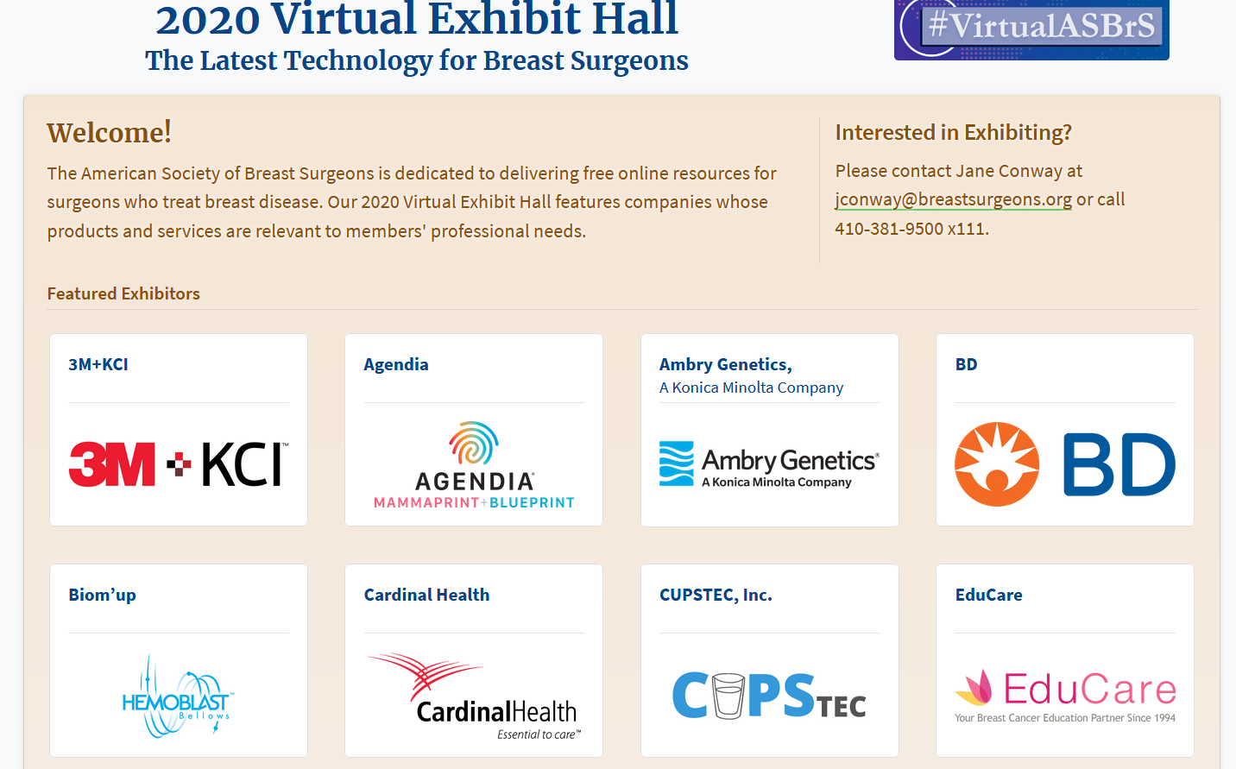

Sample Virtual Exhibit Space

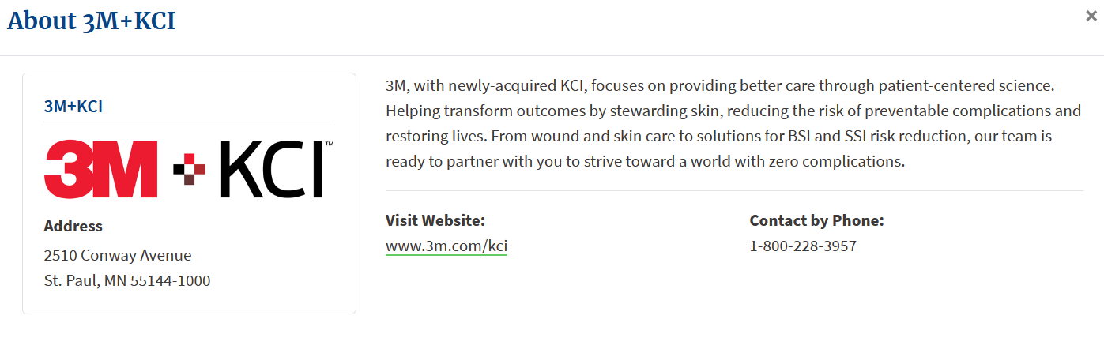

EXHIBITOR REGISTRATION FORM

ACTIVITY INFORMATION

ACTIVITY TITLE: 27th GI Symposium: Gastrointestinal and Liver Disorders:
Developments in Last Year

ACTIVITY DATE: October 29, 2021 COURSE CODE: 22MR02
RUTGERS-CCOE CONTACT: Olinda Perez EMAIL: olinda.perez@rutgers.edu

COMPANY INFORMATION

COMPANY NAME: __________________________________________________________________________
CONTACT PERSON: _________________________________________________________________________
BUSINESS ADDRESS: ________________________________________________________________________
CITY: STATE: ZIP: ______________
BUSINESS PHONE: E-MAIL:
$3,000.00 | 1 Table  2 Exhibitors | Exhibitor/Attendee Name __________________________________________  Exhibitor/Attendee Name __________________________________________

PAYMENT BY CHECK

Make check payable to Rutgers, The State University and mail to:

Center for Continuing and Outreach Education
Rutgers Biomedical and Health Sciences
30 Bergen Street, ADMC 7, Newark, NJ 07101-1709
Attention: Olinda Perez

PAYMENT BY CREDIT CARD
Visit https://rutgers.cloud-cme.com/RU27GISymposium

Click “Exhibitors” then “Exhibit at this Event” and complete the registration process.
Please complete and return this form, REGARDLESS OF FORM OF PAYMENT,
along with the signed Exhibitor Agreement,
by email to Olinda Perez at olinda.perez@rutgers.edu

