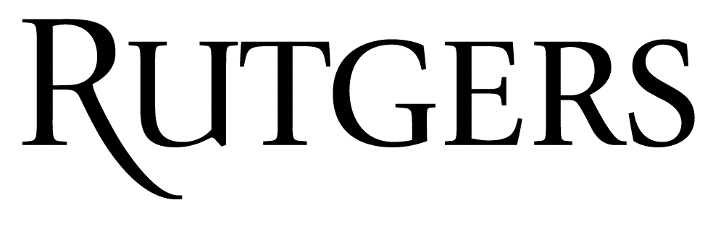 | Disclosure Declaration Form  Abstract Author
As an accredited continuing education provider, Rutgers Biomedical and Health Sciences must ensure balance, independence, objectivity, and scientific rigor in all its certified educational activities. As such, Rutgers requires all individuals in a position to control the content of an educational activity to provide a signed disclosure form prior to the planning of the activity. In order to ensure its CE activities, promote improvements or quality in healthcare and not a specific proprietary business interest of a commercial interest, Rutgers will identify and resolve all conflicts of interest prior to the planning of the activity. Based on this disclosure information, Rutgers may disqualify any individual from planning and implementation if a conflict of interest that may contribute to commercial bias is determined to exist and cannot be resolved.
Individuals are required to disclose all relevant financial relationships with commercial interests (entities producing, marketing, re-selling, or distributing health care goods or services consumed by, or used on, patients) Relevant financial relationships are financial relationships in any amount, which occurred in the twelve-month period preceding the time that the individual was asked to assume a role controlling content of the CE activity, and which relate to the content of the educational activity, causing a conflict of interest. Financial relationships create conflicts of interest in CE when individuals have both a financial relationship with a commercial interest and the opportunity to affect the content of CE about the products or services of that commercial interest. In addition, an individual developing content that provides information, in whole or in part, related to non-FDA approved uses for drug products or devices, must indicate his/her intention to Rutgers by way of this form. The individual must also clearly identify the unlabeled indications or the investigational nature of the proposed uses to the learner.

In accordance with the Standards for Commercial Support set forth by the Accreditation Council for Continuing Medical Education, the undersigned understands and accepts the policies and standards as set forth in this document.
All disclosure declarations must be communicated to the learner by means of a notation in the program or syllabus, or verbally by the activity director or moderator prior to the beginning of the activity. Individuals who do not provide the requested disclosure information will be disqualified from participating in the development and delivery of a CE activity.

Activity Title Global Neurosurgery: Ask Not for Whom the Bell Tolls
Name
Please answer all the questions on both pages and sign on page 2.

1. Do you or any member of your immediate family have any relevant financial relationships with commercial interests (entities producing, marketing, re-selling, or distributing health care goods or services consumed by, or used on, patients) in any amount within the past 12 months?
Yes No

- If Yes, please list (attach separate page if necessary) the commercial entities with the type of relationship listed below.
Grant/Research Support
Consultant
Speakers Bureau
Patent Holder
Member, Scientific Advisory Board
Member, Board of Directors
Stock Shareholder
(directly purchased)
Other Financial Support (specify)
Other Relationship/Affiliation (specify)

- If Yes, will your abstract include discussion of specific products/services of the commercial entities you’ve listed above?
Yes No
2. During the development and/or presentation of content, I attest to the following:

- The content and/or the delivery of information in my abstract will promote improvement and quality in healthcare, and will not promote a specific proprietary business interest of a commercial organization.
Yes No

- Recommendations involving clinical medicine discussed in my abstract will be based on evidence that is accepted within the profession of medicine that adequately justifies the indications and contraindications in the care of patients.
Yes No

- Scientific research referred to, reported or used in my abstract in support or justification of a patient care recommendation conforms to generally accepted standards of experimental design, data collection and analysis.
Yes No

- Research findings and therapeutic recommendations discussed in my abstract will be based on scientifically accurate, up-to-date information and presented in a balanced, objective manner.
Yes No

3. Will your abstract include discussion of unlabeled/investigational uses of a commercial product?
Yes No

- If Yes, list the specific product(s) and the off-label or medical indication(s). *

* This information must be identified and disclosed to the learners in your during your presentation.

I certify that the information I have provided is true and complete to the best of my knowledge and I accept responsibility for the accuracy of the information in response to the aforementioned questions. I will uphold academic standards to ensure balance, independence, objectivity and scientific rigor in my role in the development and implementation of this educational activity.

_______________________________________________________________________________________________
Signature Date

