August 23, 2021

RE: 3nd Annual Stroke and Neurocritical Care Symposium:
Extending the Windows and Saving Lives Beyond Expectation
Virtual Exhibit Space

On behalf of Rutgers Biomedical and Health Sciences, Rutgers Robert Wood Johnson Medical School, Departments of Neurology and Neurosurgery, and RWJBarnabas Health, we invite you to be an exhibitor at a continuing medical education activity entitled “3nd Annual Stroke and Neurocritical Care Symposium: Extending the Windows and Saving Lives Beyond Expectation” to be held as a Virtual Live Meeting on Friday, October 8, 2021.

This activity is under the direction of Kiwon Lee, MD, Professor and Chief of Service, Department of Neurology, Chief of Stroke and Neurocritical Care Division, Director of Comprehensive Stroke Center and Neurocritical Care Unit, Rutgers Robert Wood Johnson Medical School/Robert Wood Johnson University Hospital, and Anil Nanda, MD, MPH, Professor and Chairman, Department of Neurosurgery, Rutgers New Jersey Medical School and Rutgers Robert Wood Johnson Medical School, Peter W. Carmel, MD Endowed Chair of Neurological Surgery; Senior Vice President of Neurosurgical Services, RWJBarnabas Health.

The purpose of the exhibitor space is to complement the activity with topic-relevant products and services, and to further the scientific, technical, and educational advancement of our participants. A copy of the program is enclosed.

The exhibitor fee is $2,000.00. Your fee entitles you to exhibit space, handout materials, and acknowledgement in the course syllabus. Two representatives from your organization may attend the educational activity for the direct purpose of the representatives own education; however, they may not engage in sales or marketing activities while in the space or place of the educational activity. Please refer to the enclosed exhibit prospectus for further details.

If you would like to exhibit, please complete the enclosed Exhibitor Registration Form and Exhibitor Agreement and return it to me by email at olinda.perez@rutgers.edu. The tax identification number for Rutgers, The State University of New Jersey, is 46-2354111.

We appreciate your support of this important educational event in our community and in assisting us to raise the standard of healthcare in New Jersey. As we get closer to the meeting date, we will provide you with additional exhibit information. Should you require additional information, please contact me by email at olinda.perez@rutgers.edu.

Sincerely,

Olinda Paula Perez
Program Coordinator

Third Annual Stroke and Neurocritical Care Symposium
Extending the Windows and Saving Lives Beyond Expectations

Friday, October 8th, 2021

Exhibitor Prospectus

All exhibits include
- Company logo (icon) in virtual exhibit hall lobby
- Hyperlink from lobby to dedicated exhibit space
- Company logo and description (introductory paragraph ~ 200 words)
- Link to company web page
- Company contact information
- Up to four (4) external hyperlinks to videos, downloadable pieces and/or web sites (e.g., company social media sites, sponsor pre-develop educational content, other educational content available in the public domain, prescribing packaging information, ad page, 30 second commercial, etc.)
- 2 complimentary symposium registrations

Exhibit Cost: $2,000.00

Exhibit Assets Deadline: September 17, 2021

Dedicated Meeting
Breaks/Exhibit Times: 7:45 – 7:55 am
9:50 – 10:05 am
12:25 – 1:30 pm
3:20 – 3:35 pm

Virtual exhibit hall will be accessible throughout the meeting.

Sample Virtual Exhibit Hall Lobby

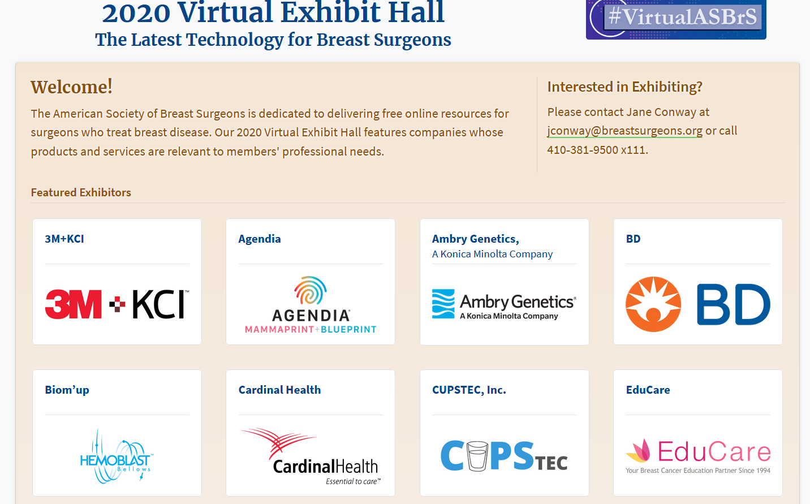

Sample Virtual Exhibit Space

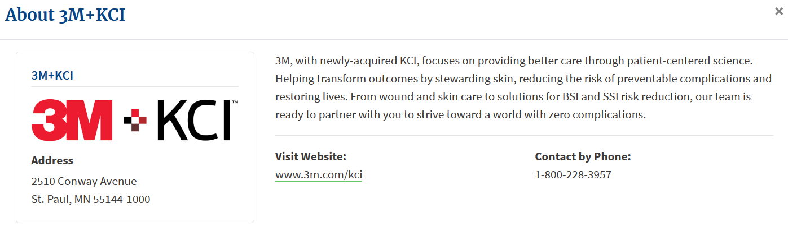

EXHIBITOR REGISTRATION FORM

ACTIVITY INFORMATION
ACTIVITY TITLE: Third Annual Stroke and Neurocritical Care Symposium: Extending the Windows and Saving Lives Beyond Expectations

ACTIVITY DATE: Friday, October 8, 2021 COURSE CODE: 22MR07
RUTGERS-CCOE CONTACT: Olinda Perez EMAIL: olinda.perez@rutgers.edu

COMPANY INFORMATION

COMPANY NAME: __________________________________________________________________________
CONTACT PERSON: _________________________________________________________________________
BUSINESS ADDRESS: ________________________________________________________________________
CITY: STATE: ZIP: ______________
BUSINESS PHONE: E-MAIL:
$2,000.00 | 1 Table  2 Exhibitors | Exhibitor/Attendee Name __________________________________________  Exhibitor/Attendee Name __________________________________________

PAYMENT BY CHECK

Make check payable to Rutgers, The State University and mail to:

Center for Continuing and Outreach Education
Rutgers Biomedical and Health Sciences
30 Bergen Street, ADMC 7, Newark, NJ 07101-1709
Attention: Olinda Perez

PAYMENT BY CREDIT CARD
Visit https://rutgers.cloud-cme.com/2021SNCCSymposium

Click “Exhibitors” then “Exhibit at this Event” and complete the registration process.
Please complete and return this form, REGARDLESS OF FORM OF PAYMENT,
along with the signed Exhibitor Agreement,
by email to Olinda Perez at olinda.perez@rutgers.edu

